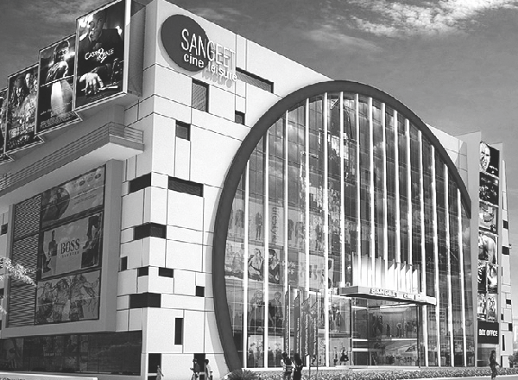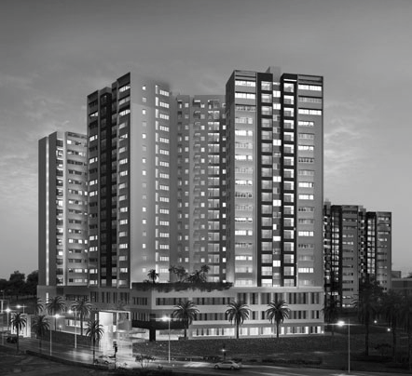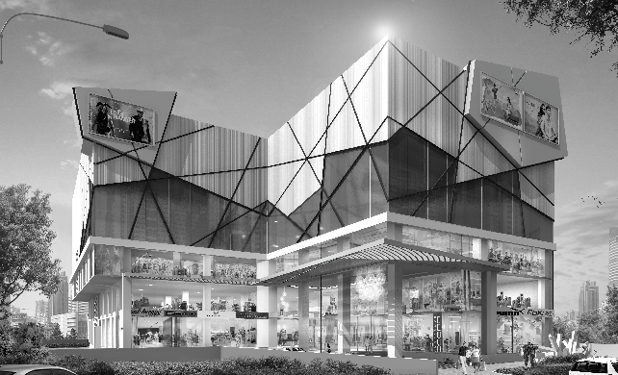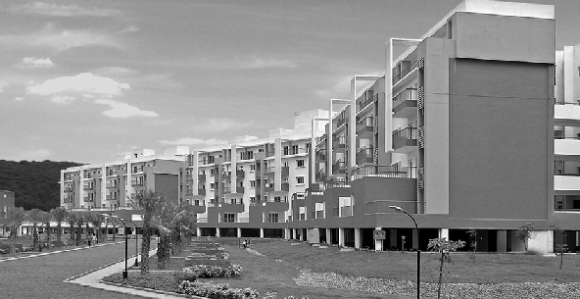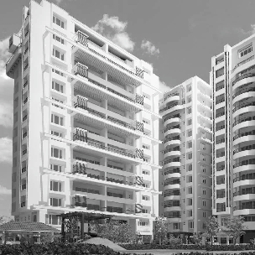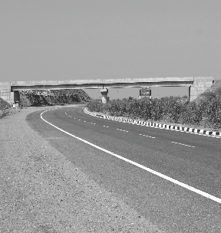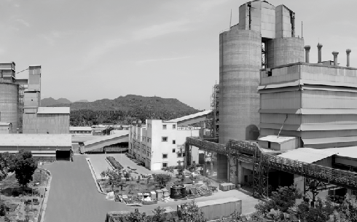

Looking down upon every minute detail to rise above all

VISION

To rise up to the top of the rung in the Civil Engineering and Construction industry and make the society look up to Elite as an entity that stands out for its magnitude, expertise, integrity and magnanimity.

MISSION

Elite aspires to attain corporate glory in its chosen domain by-

* Placing a premium on people and constantly honing their skills and inspiring them to achieve glory.
* Developing such Systems and process by which quality and timelines become automatic byproducts.
* Fostering a culture of peace and harmony amongst all stakeholders and the society around it

a small step towards a gaint leap!



Any journey begins with a small step

We at Elite Engineering and Construction (EEC) are driven single- mindedly in our pursuit to establish ourself as one of the best in the construction industry.

It started in 2007 when Elite came on to the Civil Engineering & construction scene as Elite Engineering & Construction (Hyd) Private Limited, with its corporate office at Hyderabad in (now) Telangana State. Elite later expanded its operations to Karnataka, Tamil Nadu and Kerala and has a regional office at Chennai.

Elite of course rode on the robust shoulders of its promoters who had by then a decade of experience in the industry, having worked with the leading engineering & construction companies in India. An experience and competence that would set Elite on its course to reach right to the top!

# competence

Within construction industry Elite has made its mark in certain specialized segments viz.

* Major Industrial Heavy duty floorings
* Railway Bridges
* Swimming Pools
* Cement Manufacturing Factories
* Power Plant Structures
* Toll Plaza Buildings
* Construction of Multiplex Complex
* Building Finishing works
* Plumbing & Sanitary works

Residential Buildings, Industrial structures, Institutional Buildings, Commercial Complexes including Infrastructure projects like Roads, Bridges and Logistic facilities.

Along the way Elite has also expanded its expertise into other specialized works/projects including:

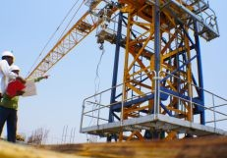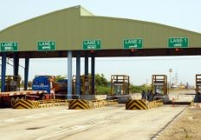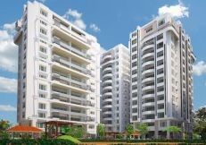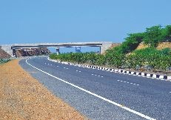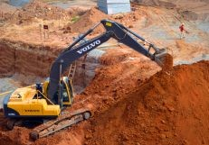

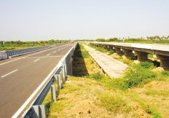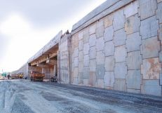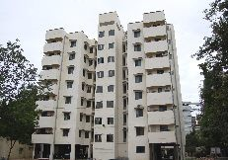

# why EEC?

Zero tolerance towards quality commitment

Elite keeps a constant check on the quality systems and processes at each stage to avoid bad workmanship. Elite has good expertise in vendor management, material handling, labour psychology with internal and checks and balances to keep a tab on work schedule and specifications to deliver unmistakable quality.

Elite understands that its commitment to quality is just not to the client but to the public at large, since all the constructions are by and large meant for public use.

Timelines are rarely negotiable

With a reputation for successfully delivering projects of various sizes and complexities on time every time, Elite has carved a niche and earned the trust of its customers. The company achieves this through the know-how of its people, by continually evolving its work-flow processes/methods and by investing into improvement of its technical and managerial competence.

Cutting costs, not corners for the clients

Elite excels in working within the budgetary constraints by optimizing its resources, both men and machinery. Having its own equipment and completing projects within timelines puts a tab on cost escalation, the benefit of which is passed on to the client. Backward integration is a constant endeavor at Elite which benefits the clients in terms of costs and timelines.

## quality

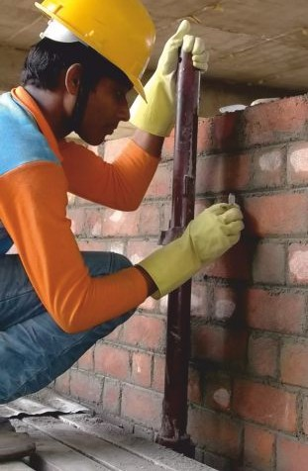

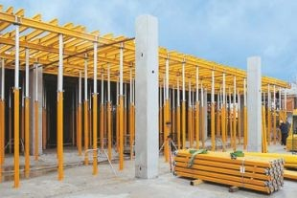Quality is the basis on which Elite’s operations are conducted. We recognize the importance of providing quality assured service to our customers. In the same spirit, we encourage all our suppliers, consultants and project partners to apply rigorous quality processes in their operations.

The construction quality process includes:

* Trade assessment and compliance certification
* Building control services involving inspection and compliance

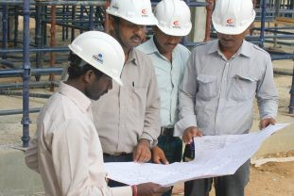

* The appointment of a foreman to oversee the works and communicate the scope and detailed requirements of the project
* The construction programme that provides guidance for planning and preparation of the work.

Elite group’s meticulous planning prior to the start of construction provides the foundation on which every subsequent step is based. Addressing critical details during preconstruction frequently results in fewer construction-phase changes, reduced construction time, and cost savings. It also ensures that the finished product meets a client's needs.

Elite’s policy to work closely with the client and design team has produced great results. We develop and maintain accurate construction cost estimates as well as analyze scheduling, materials, building systems, and construction methods. We also get input from our in-house experts in such disciplines as mechanical and electrical systems, foundations, structural detailing, and purchasing.

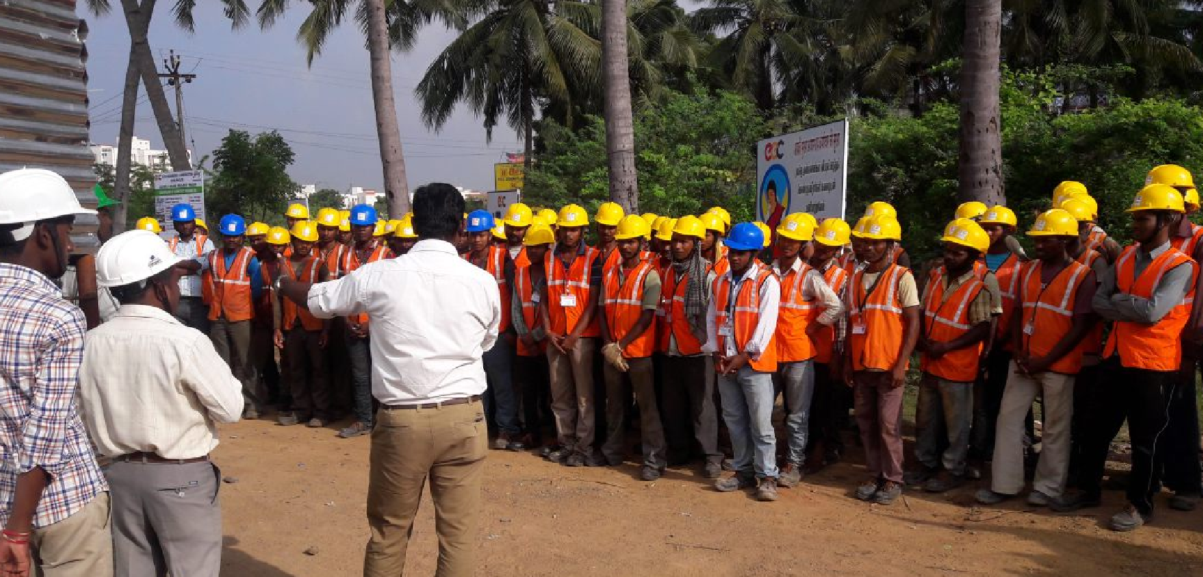

## safety

The company strives to attain and maintain high standards of environment, occupational health and safety at all places, defined by the organization besides adhering to legal and other requirements.

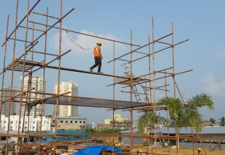The company is committed to managing its construction process and other operations to ensure minimum wastage. Also prevent various types of pollution and minimize occupational health and safety risks through continual process and technology improvements.

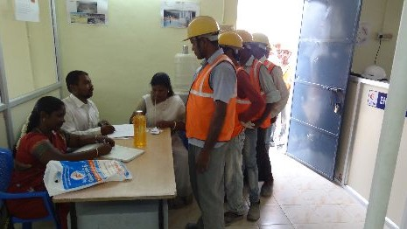 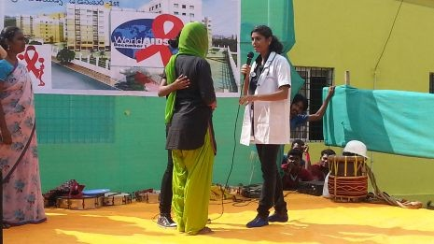

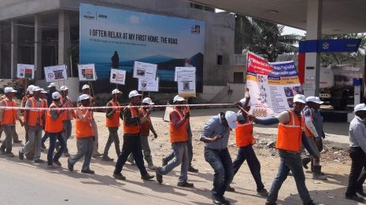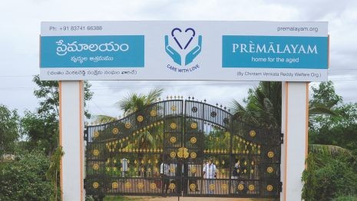

## social responsibility

Elite is aware that it is but just a small element trying to make its presence felt in the microcosm of Society surrounded by the macrocosm of the environment. And hence, all the actions of Elite are constantly reviewed to ensure that it make a positive impact on the society and no negative impact on the environment.

The Corporate Social Responsibility (CSR) policy and the Environment, Health and Safety (EHS) policy of Elite are designed and implemented to make a profound and positive impact on both the spheres.

## clientele

In its not-so-long journey, Elite has still managed to build impressive landmark projects which it could always look back with pride and has earned the trust and gratitude of customers with which it could always go further in its journey. It clients list includes the MNCs to Indian PSUs to Institutions to Private undertakings while the list of projects are also as varied. Whatever the constitution of the client or the nature of the project, Elite’s fundamentals to deliver customer satisfaction always remained prime.

* + Ascendas IT Park (VITP Pvt. Ltd.), Hyderabad
  + Cognizant Technology Solutions India Pvt. Ltd., Hyderabad
  + EMAAR-MGF, Hyderabad
  + Indian Institute of Technology, Madras, Chennai
  + IL & FS Engineering Services, Hyderabad.
  + Ramco Cements Ltd., Chennai
  + Madhucon Projects Ltd., Hyderabad.
  + Metro Cash & Carry India Pvt. Ltd, Bangalore
  + Seth Ghasiram Gopi Kishan Badruka Educational Trust, Hyderabad
  + Somana Entertinment Pvt. Ltd., Secundrabad
  + Techtrans Construction (India) Pvt. Ltd., Hyderabad
  + Vermont Projects Pvt. Ltd., Hyderabad
  + Namishree Infrastructure and Projects Pvt. Ltd., Hyderabad
  + Srinivasa Shipping and Property Development Limited (SSPDL), Hyderabad
  + Navin Housing & Properties Pvt. Ltd., Chennai
  + Slate - The School, Tirupati
  + Godrej Properties Ltd.

## Management

Elite understands that it’s people who make the difference. And it also believes that it should have people who could bring in the difference. It helps to know the vision, passion, expertise and experience who would take Elite places.

S.V. Gurusamy, Chairman & Managing Director

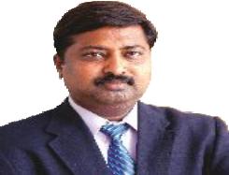

Mr S.V Gurusamy’s commitment to quality and passion for perfection has helped Elite build a strong foundation of trust with all stakeholders. His stints in various capacities with big giants in the construction industry have sharpened his business acumen which played a key role in Elite’s growth story. His innovative and dedicated approach to every project undertaken by Elite has placed Elite in a preeminent position in the industry.

Subhash Kumar Jain, Director



Mr Jain has good experience in marketing of building materials and equipment spanning 16 years. Associated with Elite since 2007, his commitment and dedication has helped in building a strong base of vendors with harmonious vendor relationship and procurement management.

S.V.Arumugam, Director



Mr Armugam’s experience of more than 16 years in infrastructure and industrial buildings arena has added tremendous importance to Elite's brand value. Associated with Elite since June 2007, he is well known for taking overall responsibility of people management, vendor development and ownership from conceptualization to execution.

S.V.Srinivasan, Director

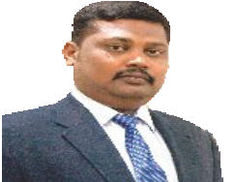

Known for his strong techno-commercial acumen, Mr Srinivasan has an experience of more than 11 years in areas of commercial and business development. Associated with Elite since June 2007, his knowledge, experience and expertise in client management and operations hold immense importance in the growth of Elite Group.

S. Sunder, Additional Director

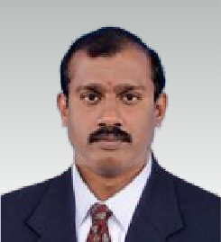

Specialized in areas of contracts and project management, Mr Sunder brings an experience of 18 years in construction industry. He has been associated with Elite since January 2009 and currently handles project planning and quality assurance.

Venkateswara Prasad, General Manager

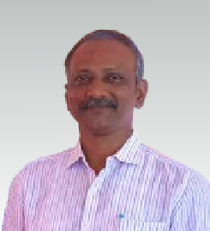

A civil engineer over 25 years in Construction Field. Mr. Venkateswara Prasad has extensive experience in construction and has handled various types of projects (in different portfolios) like Software Parks, Commercial, Industrial, Institutional and Residential Buildings etc., including co-ordination of Electro- Mechanical work.

P. Murugesan, General Manager

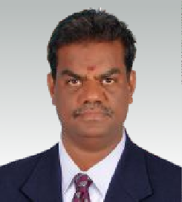

Construction manager with over 21-years of exemplary record in end-to-end implementation of various constructions, infrastructure, superfund and environmental projects. Experience includes managing a crew of over 300 workers deployed in residential projects. Backed up by impressive professional credentials including an array of on-time, within-budget, top- quality project delivery capabilities

## projects

### Project Location Client Description

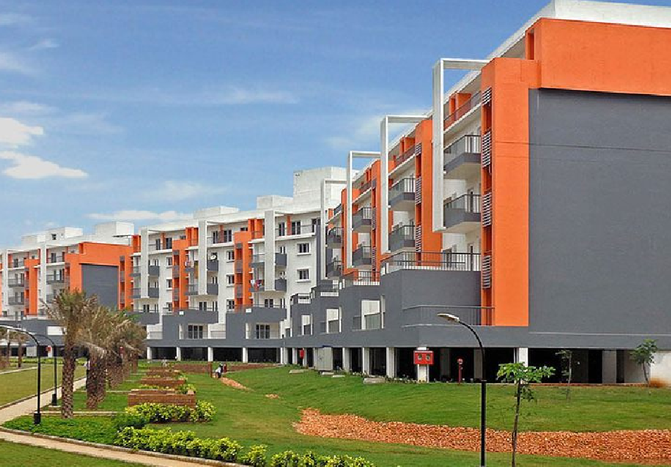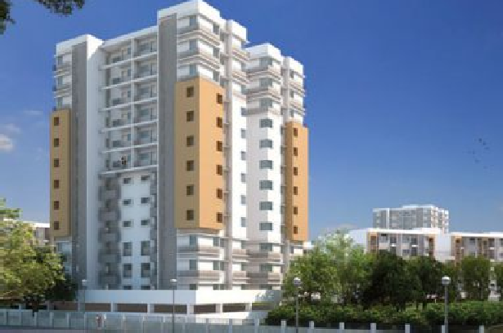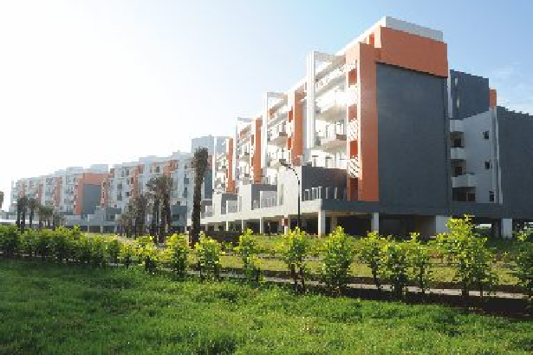

COMPLETED

Mahindra Iris Phase-1 & 2 Mahindra World City, Chengalpet

Mahindra Integrated Township Pvt. Ltd. Residential apartments

Project Location Client Description

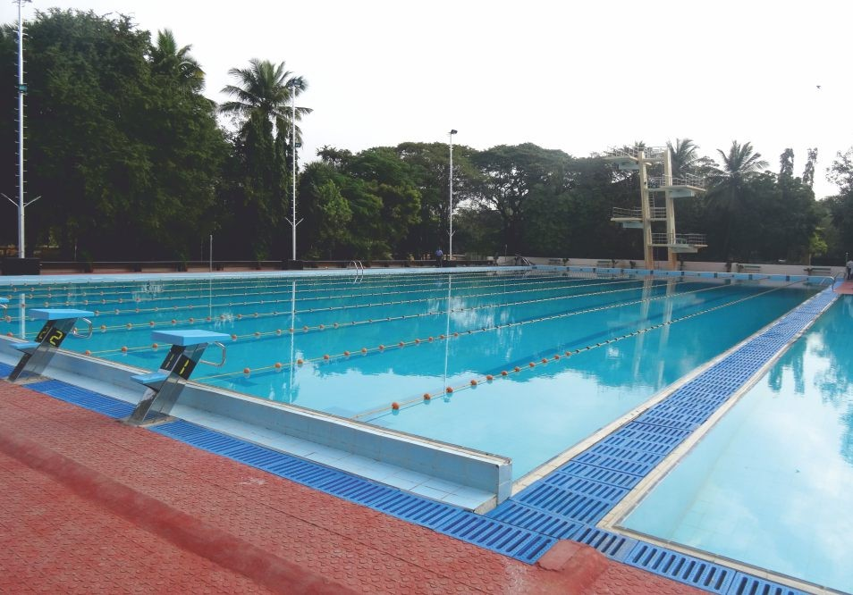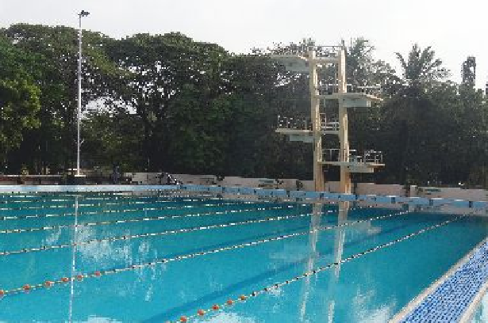

COMPLETED

International Swimming Pool Chennai

IIT Madras, Chennai Olympic standard pool



Project Location Client Description

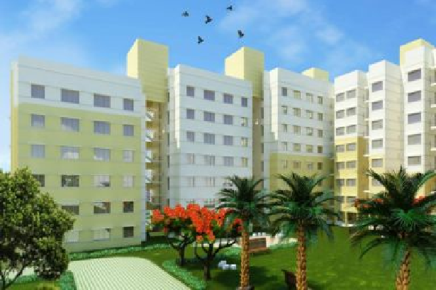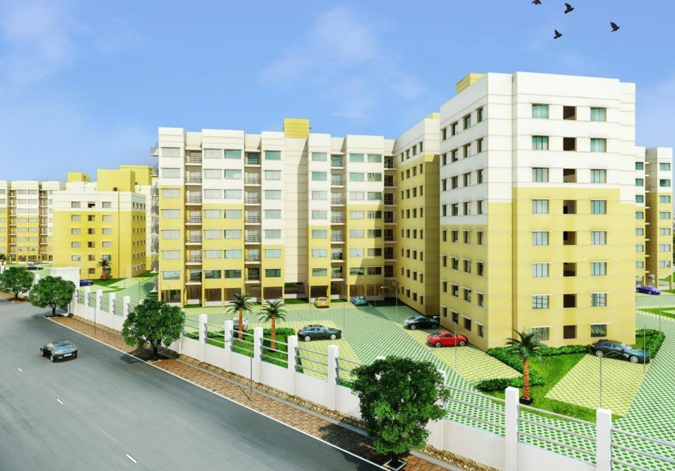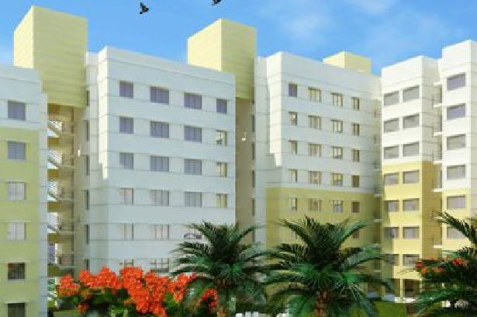

Nova Phase-1&2 at Mahindra World City Chengalpet, Tamil Nadu

Mahindra Integrated Township Ltd. Residential Apartments

COMPLETED

(Phase-2 construction is in progress)

Project Location Client Description

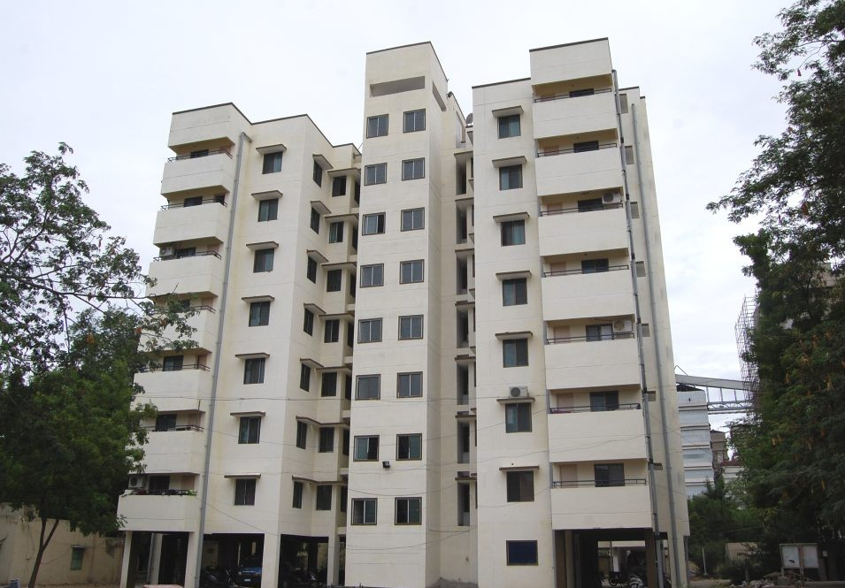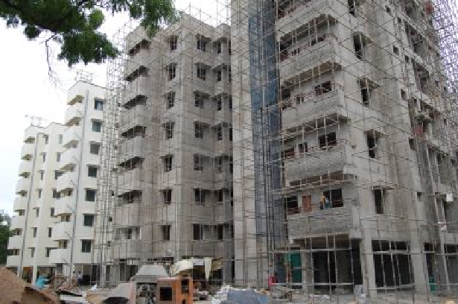

COMPLETED

F Type Quarters

RR Nagar Township Ramco Cements Ltd.

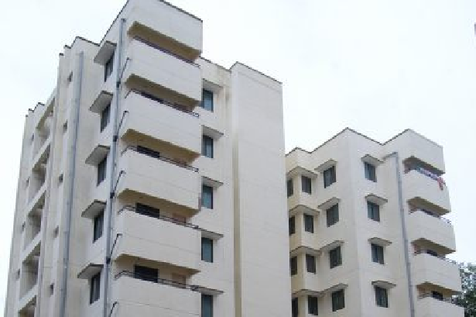

3 blocks of Stilt + 7 floors

Project Location Client Description

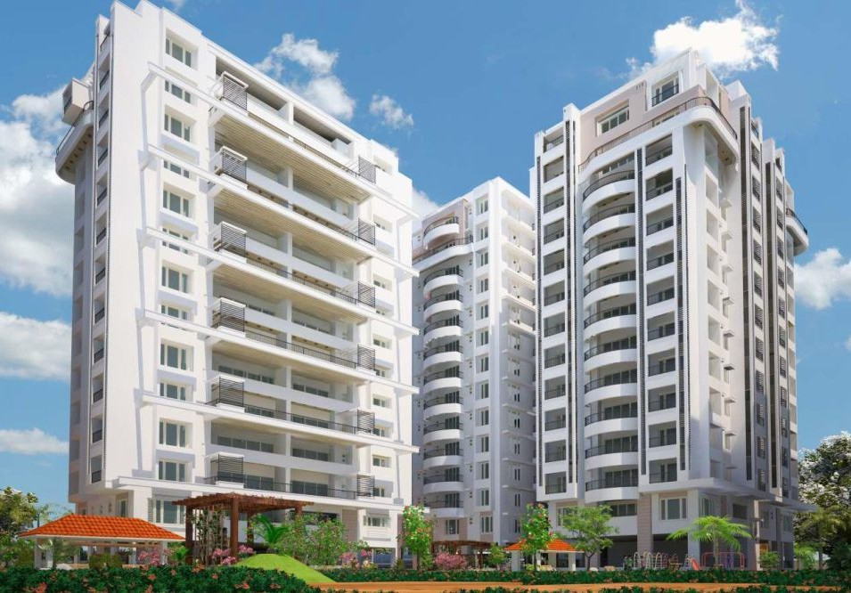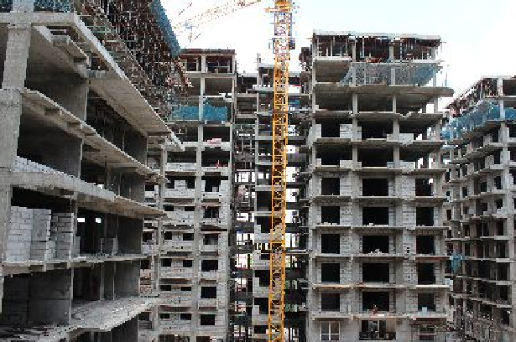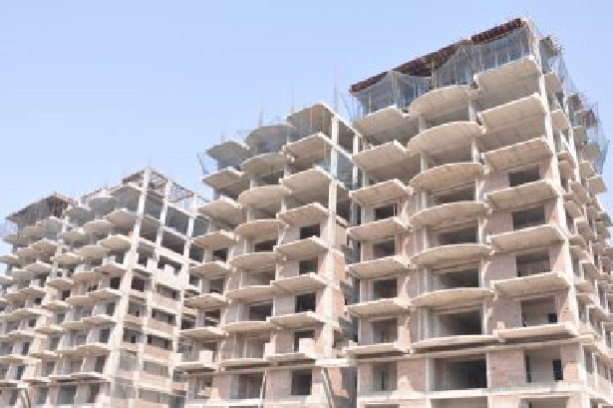

COMPLETED

Welkin Park Begumpet, Hyderabad

Vermont Project Pvt. Ltd. Luxury residential apartments

Project Location Client Description

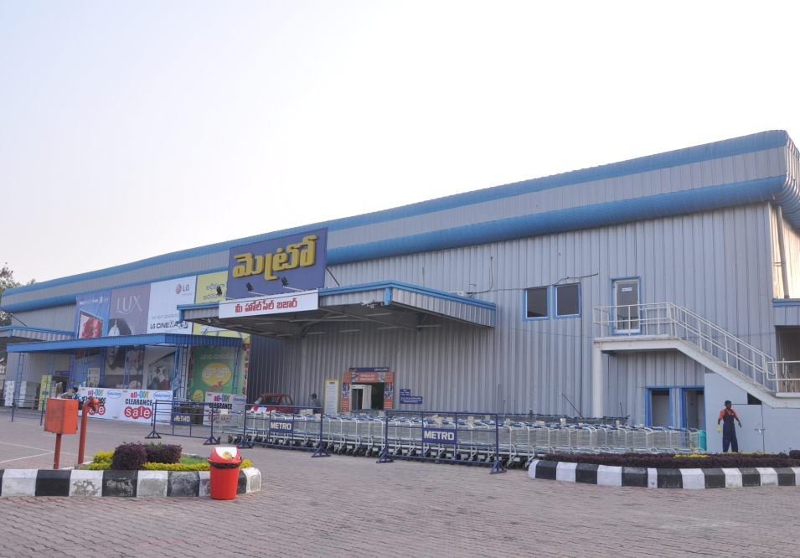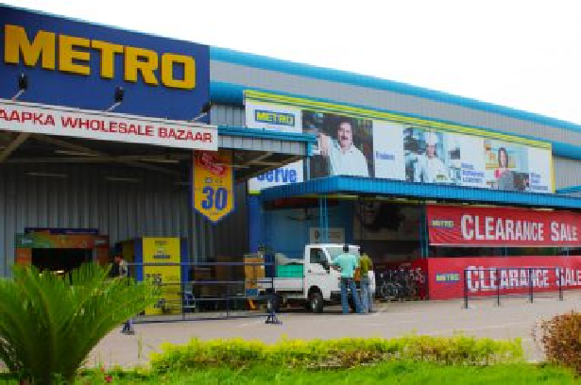

COMPLETED

Metro Cash & Carry Uppal, Hyderabad

Metro Cash & Carry India Pvt. Ltd. Metro Cash & Carry distribution center

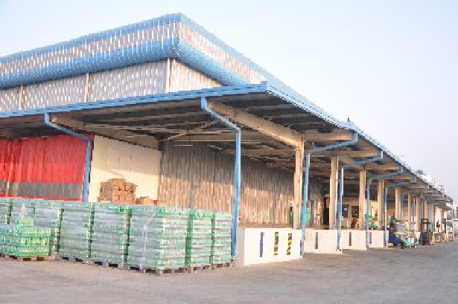

Project Location Client Description

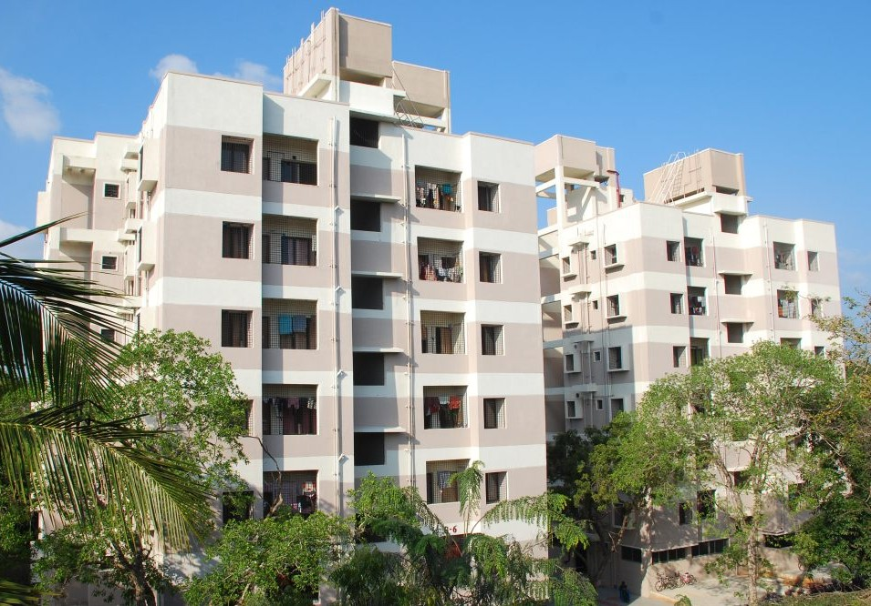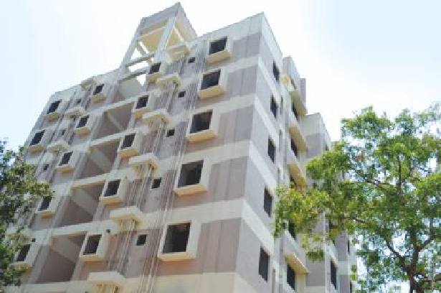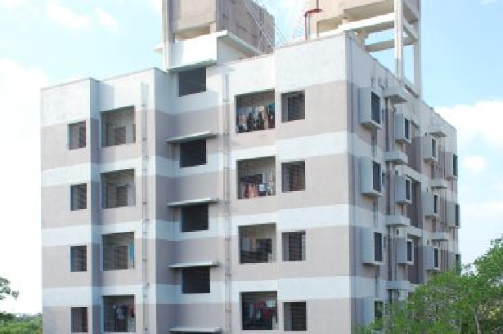

COMPLETED

F-Type accommodation IITM Campus, Chennai IIT Madras, Chennai

60 nos. of F-Type, married research scholars accommodation

Project Location Client

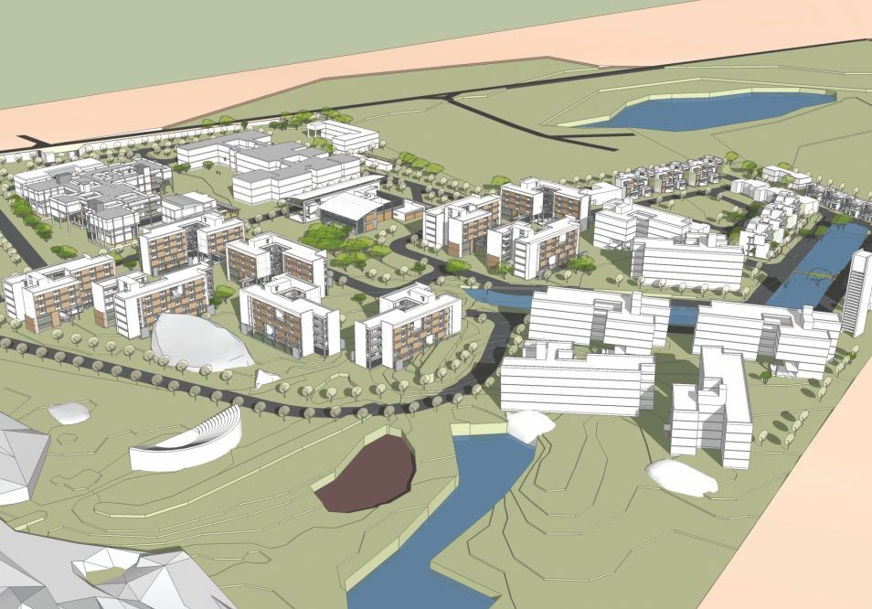

COMPLETED

Description

Badruka School of Management Medchal, Hyderabad

Seth Ghasiram Gopi Kishan Badruka Educational Trust, Hyderabad Construction of civil and structural works including facility, academic, boys & girls hostel, dining and other external

works.

Project Location Client Description

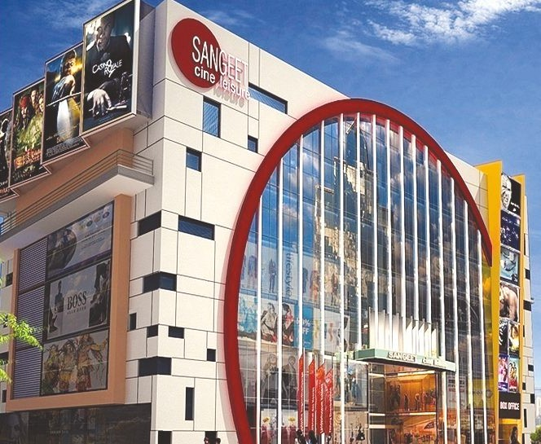

COMPLETED

Sangeet Cine leisure Secunderabad

Somna Entertainment Pvt. Ltd. Mall cum multiplex

Project Location Client Description

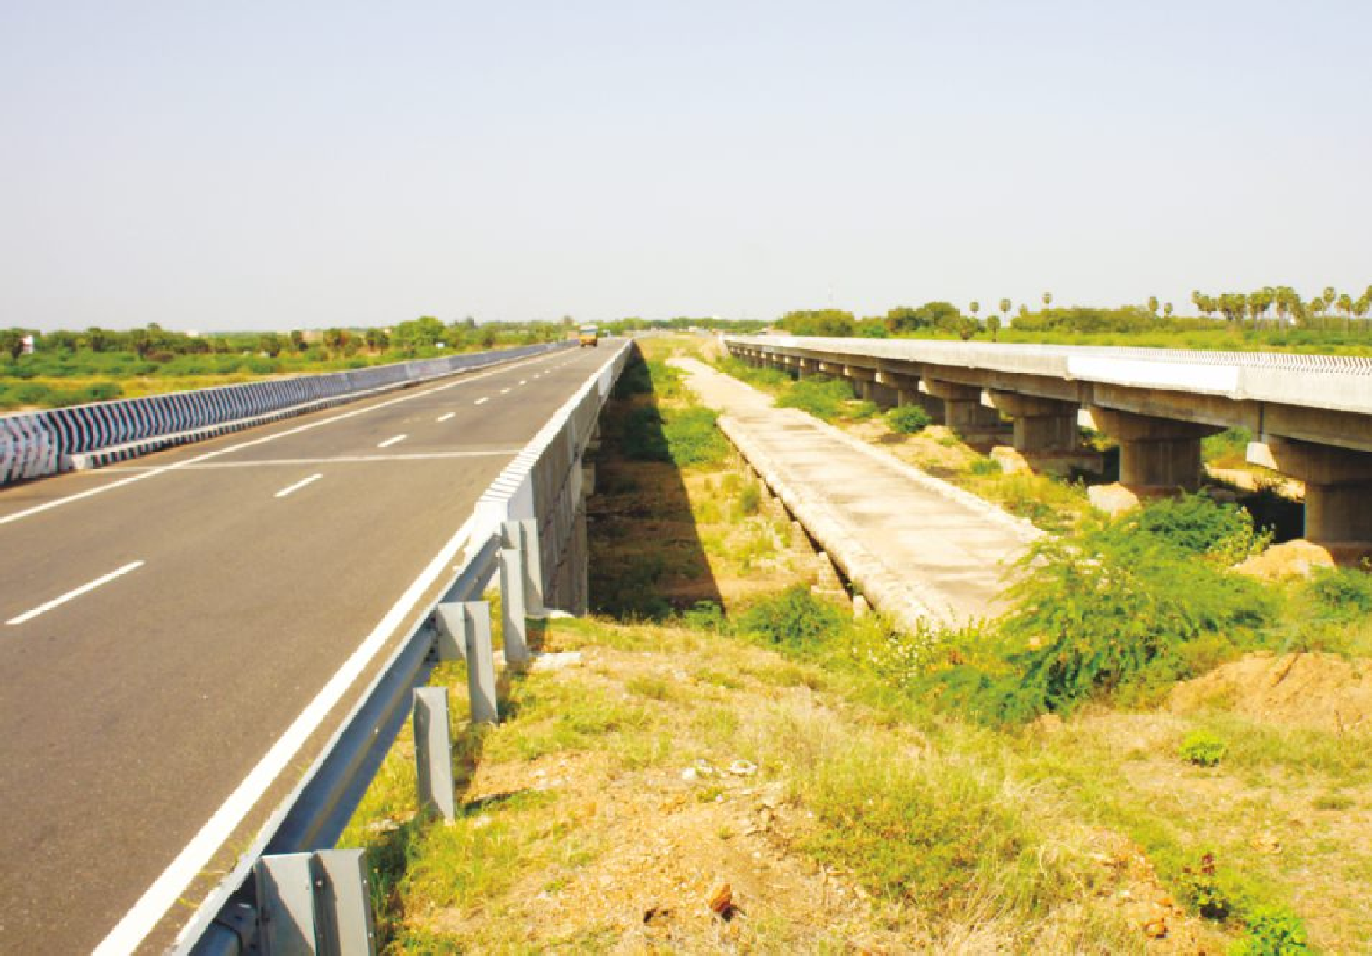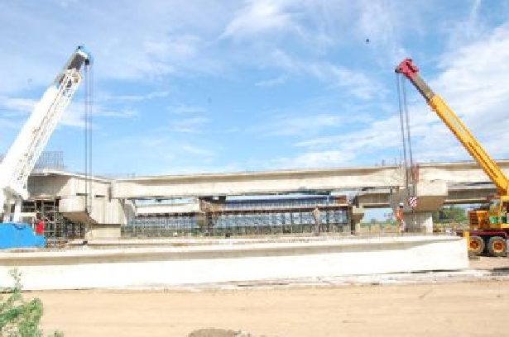

COMPLETED

Major Bridge

NHAI 45 B, Madurai to Tuticorin Maducon Projects Ltd.

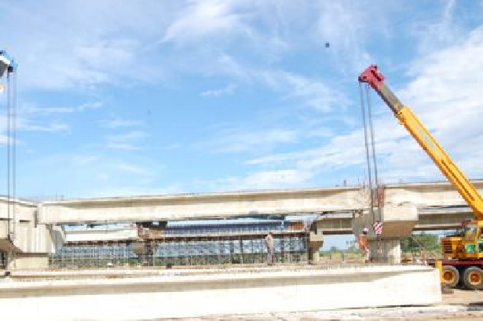

21 nos. x 32 meter span major bridge

Project Location Client Description

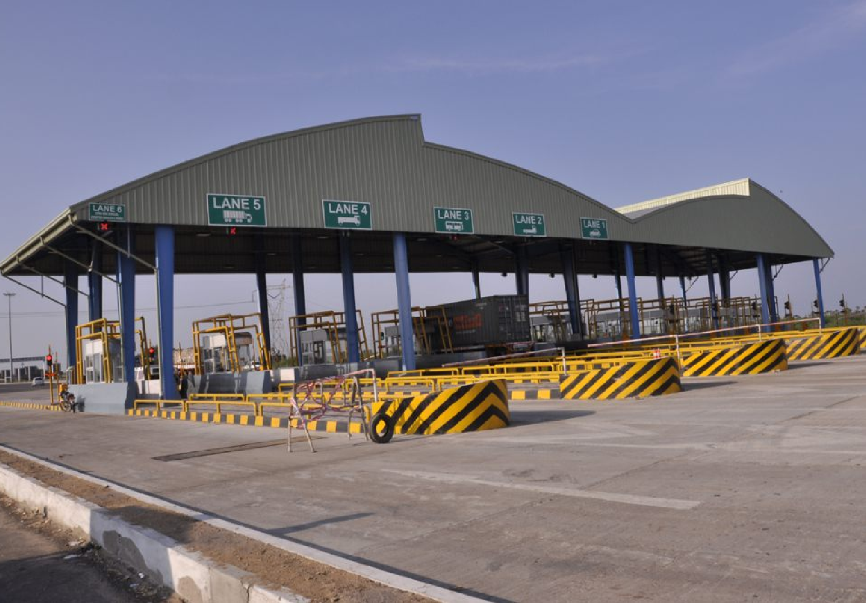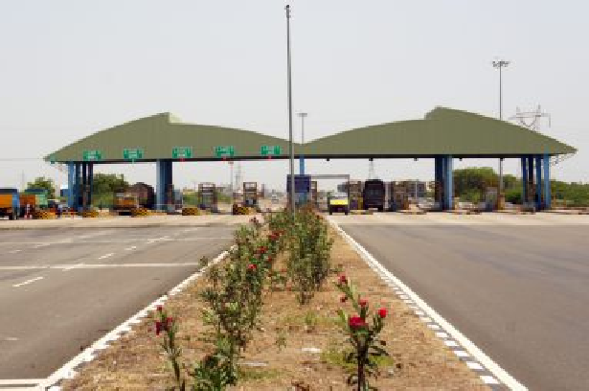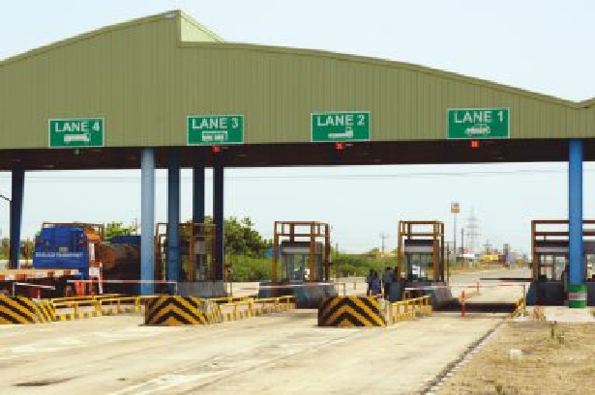

COMPLETED

Toll Plaza

NHAI 45 B, Madurai to Tutucorin Maducon Projects Ltd.

Toll plaza and control building

Project Location Client Description

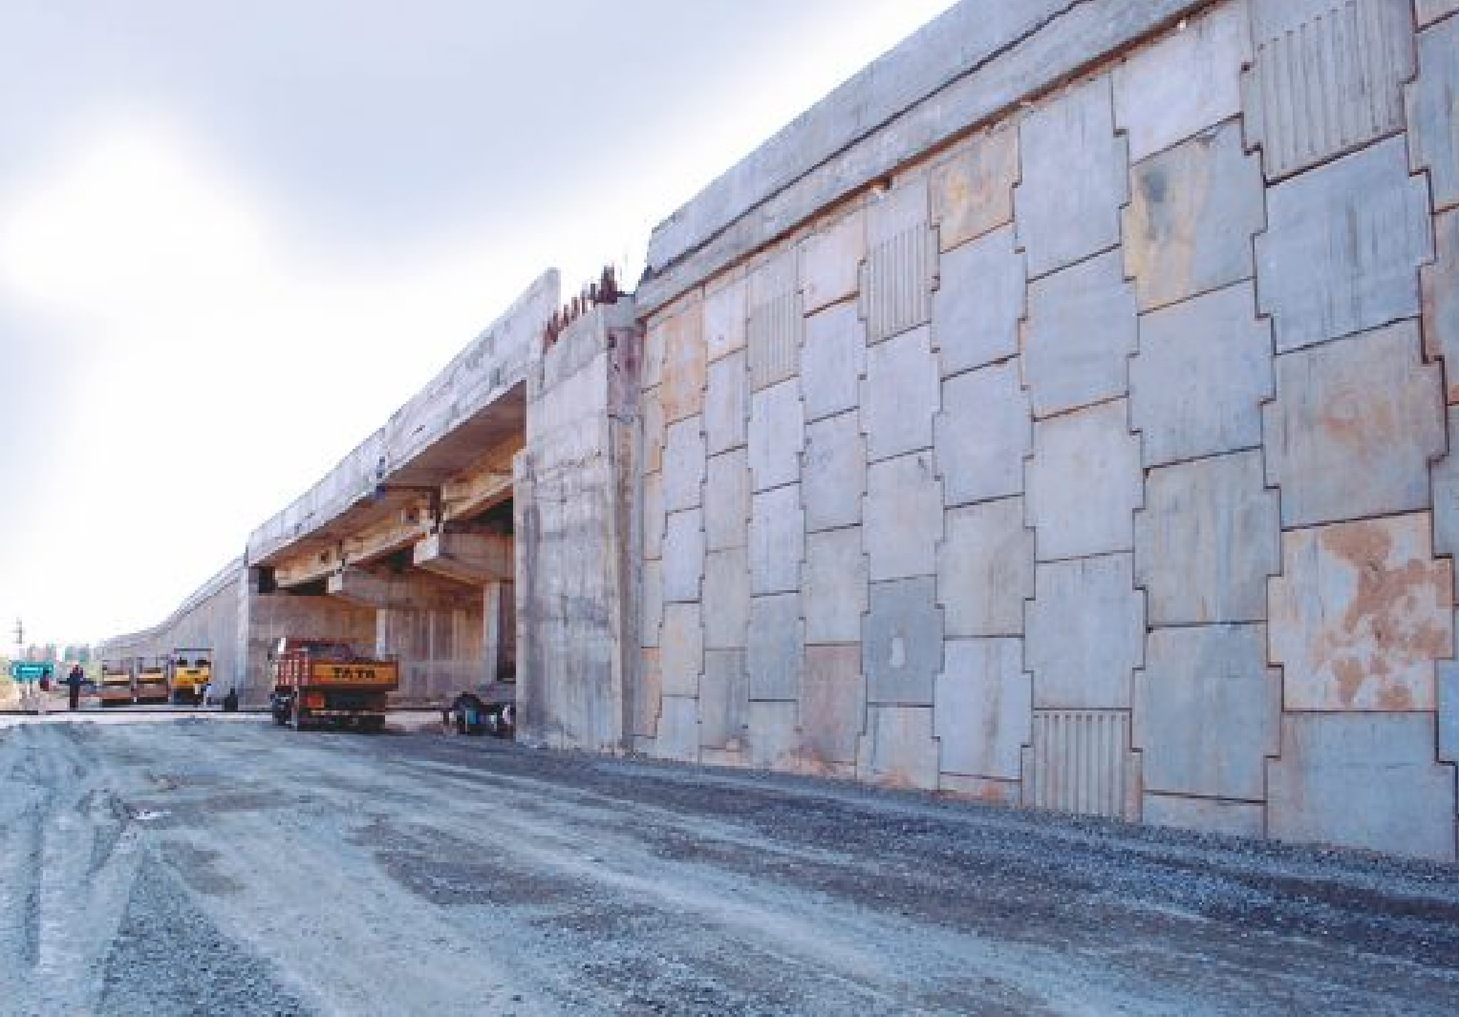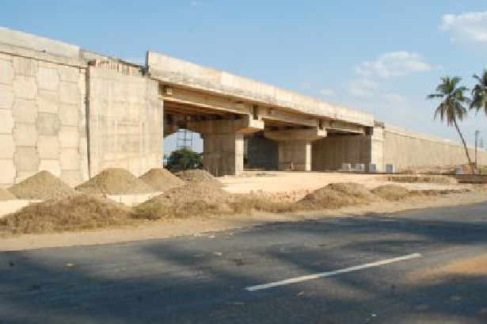

COMPLETED

Railway over bridge

NHAI 67, Tanjore to Trichy Maducon Projects Ltd.

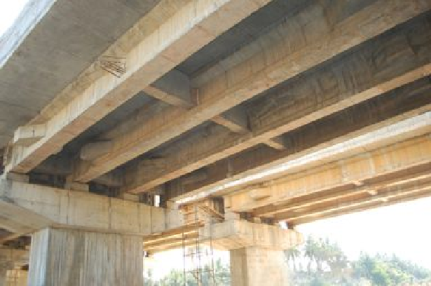

3 span railway over bridge

Project Location Client Description

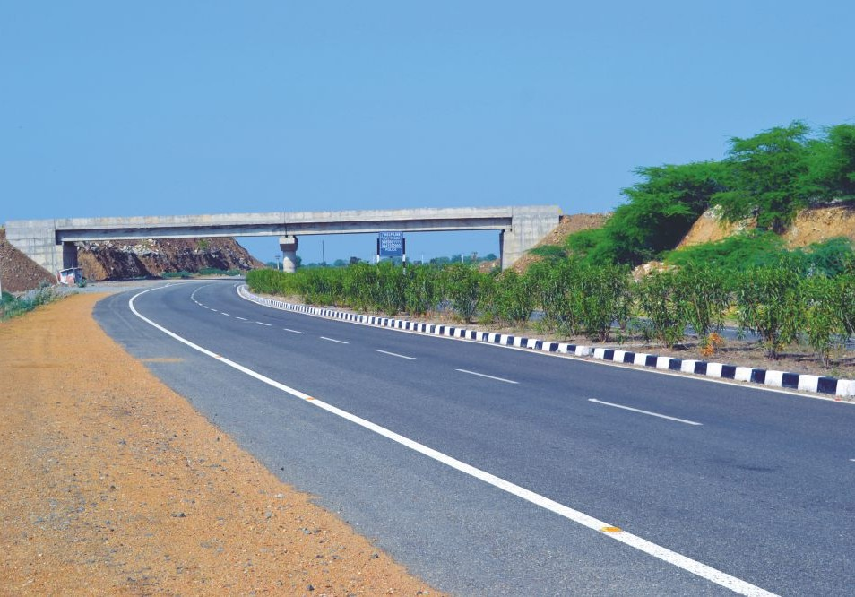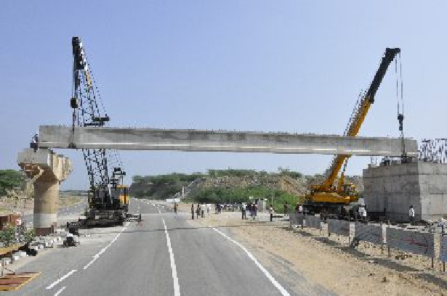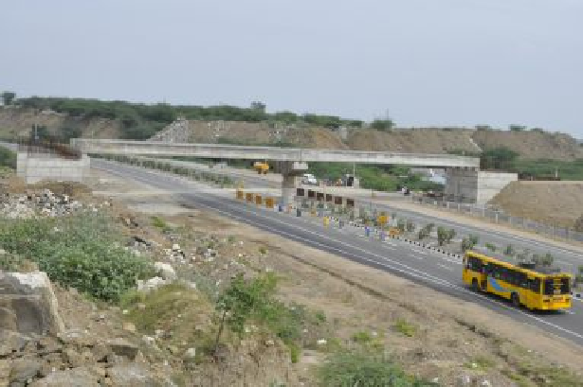

COMPLETED

Flyover bridge

NHAI 45 B, Madurai to Tutucorin Ramco Cements Ltd.

Flyover bridge and approach ramps on either ends of NH crossing on MPG miners road at Pandalgudi for

RR Nagar plant, Tamil Nadu

Project Location Client Description

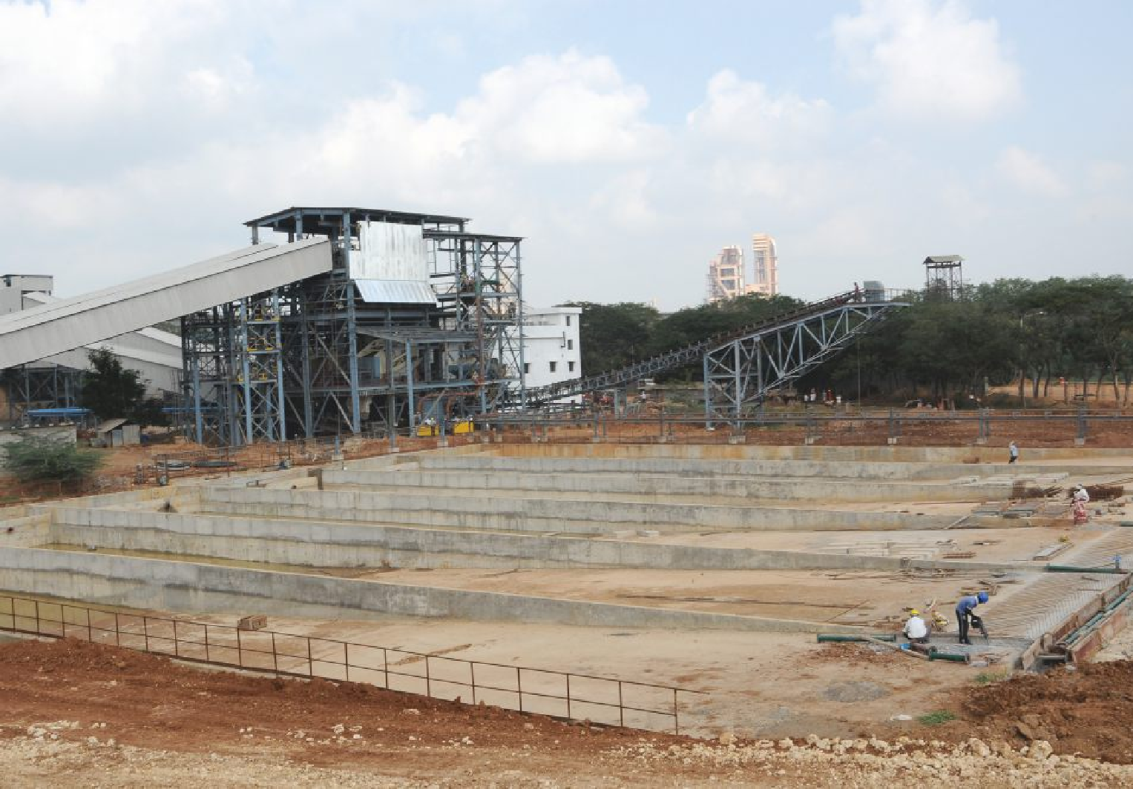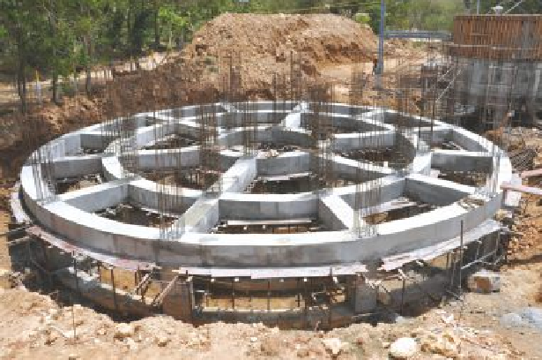

COMPLETED

Limestone Benefication Plant Alathiyur, Tamil Nadu Ramco Cements Ltd.

Limestone washing and processing plant

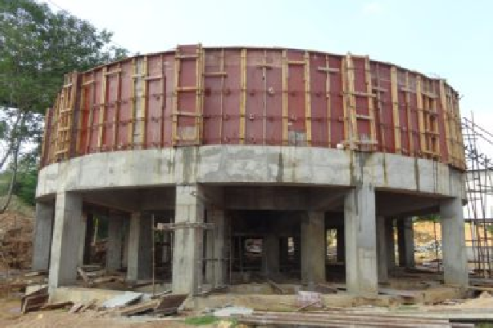

Project Location Client Description

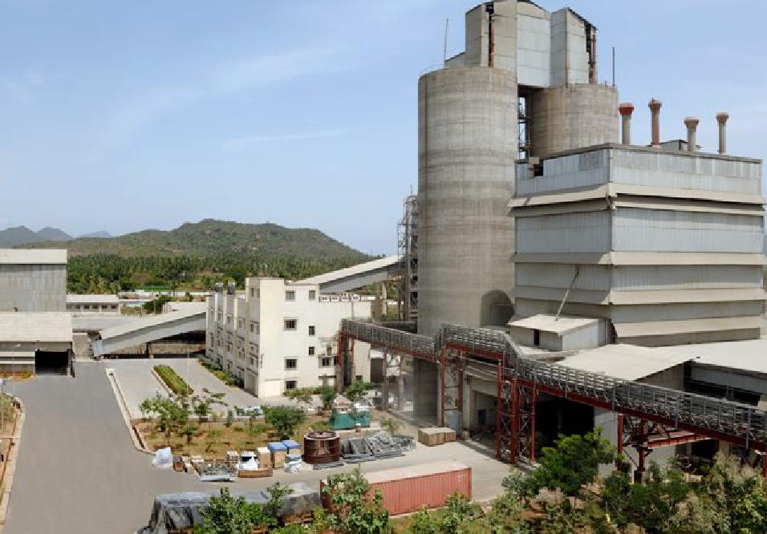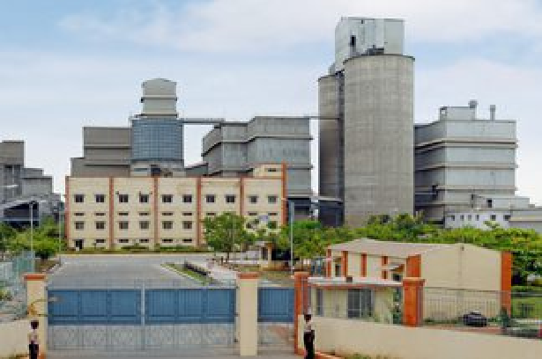

COMPLETED

6MW Power Plant Alathiyur, Tamil Nadu Ramco Cements Ltd. 6MW captive power plant

Project Location Client Description

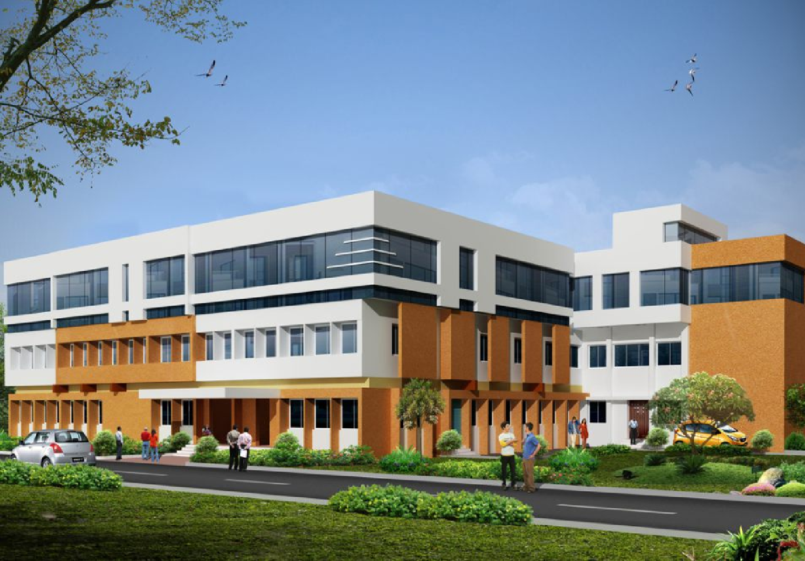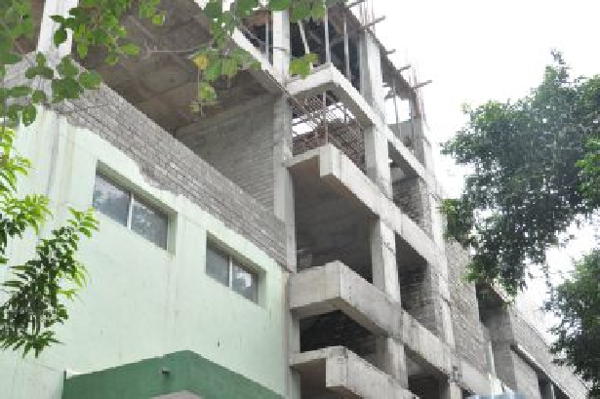

COMPLETED

Nano Technology Center IITM, Chennai

IIT Madras, Chennai

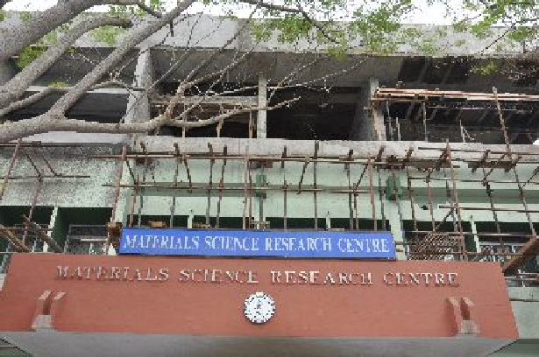

Materials science research center

Project Location Client Description

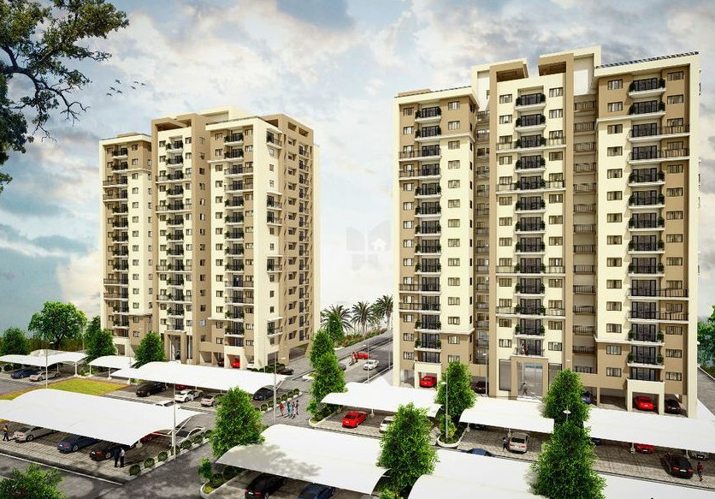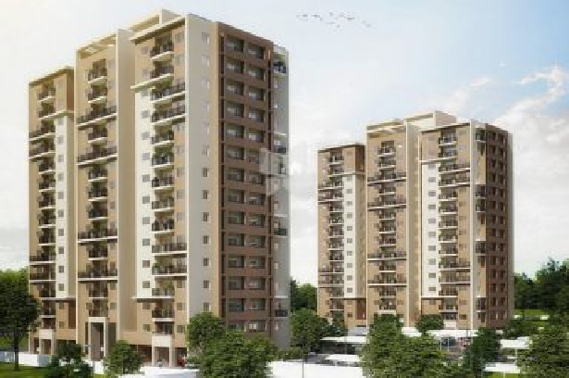

ONGOING

INCOR PBEL City Phase-2 Kanchipuram, Tamilnadu

PBEL Property Development (I) Pvt Ltd Construction for architectural civil works for proposed township

Project Location Client Description

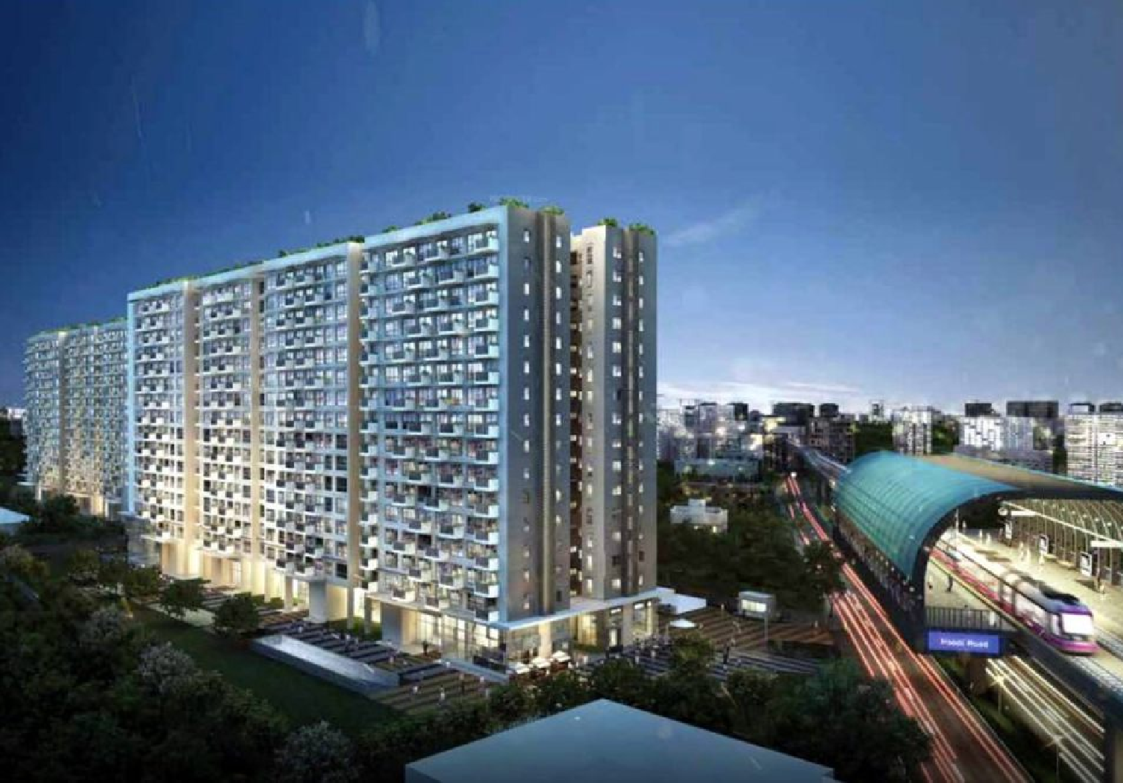

ONGOING

Godrej AIR

White Field Road, Bengaluru M/s. Godrej Housing Projects LLP Construction of Shell and Core works for Godrej Vizag Residential Development Project

Project Location Client

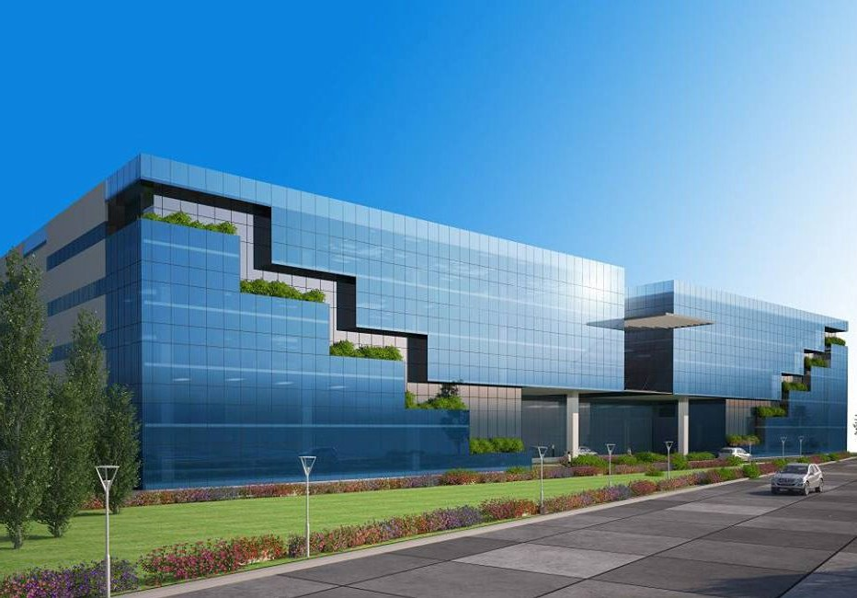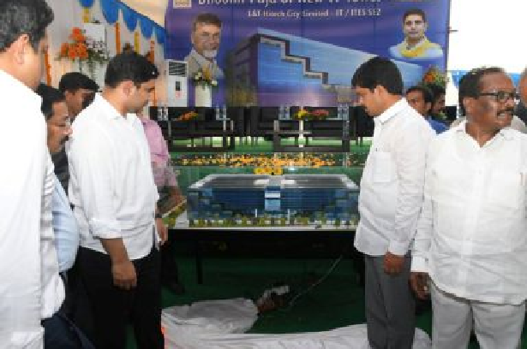

ONGOING

Description

Ace Urban Hitech City Ltd. Vijaywada, Andhra Pradesh Sri Siddharth Infratech & Services (I) Pvt. Ltd.

Civil & Structural Works for IT Park Building - 2

Project Location Client Description

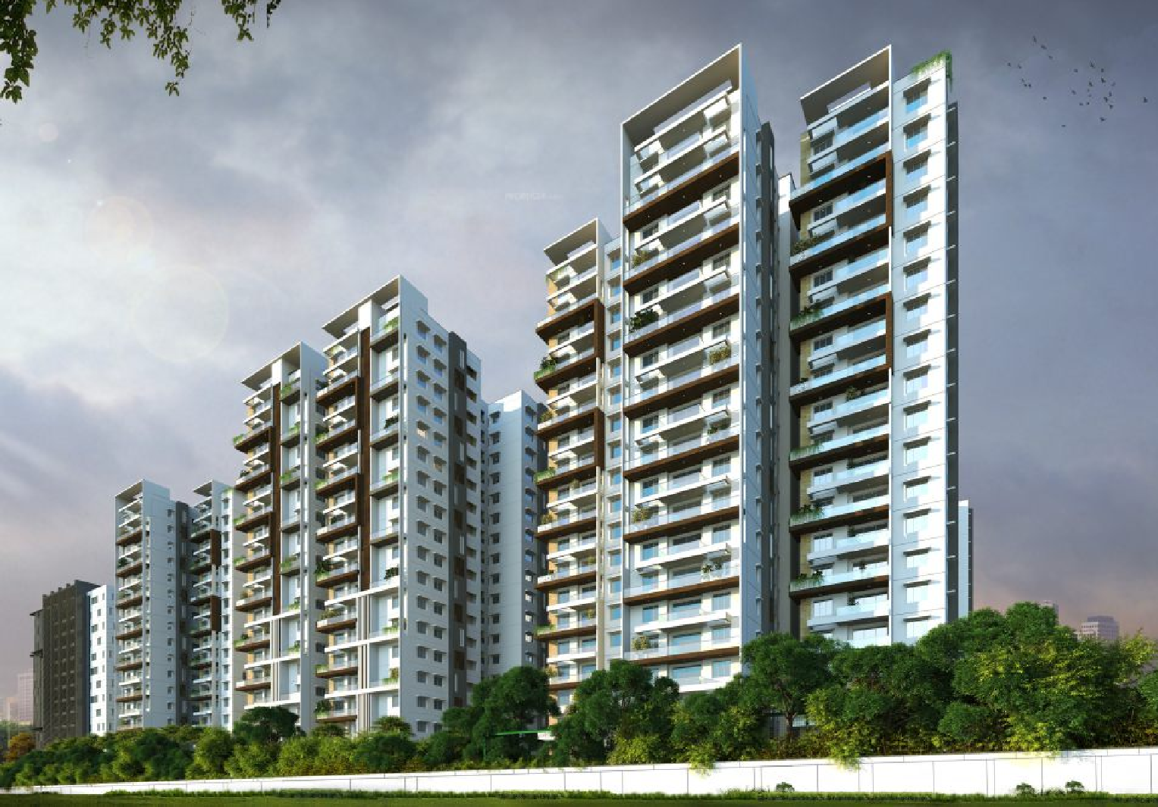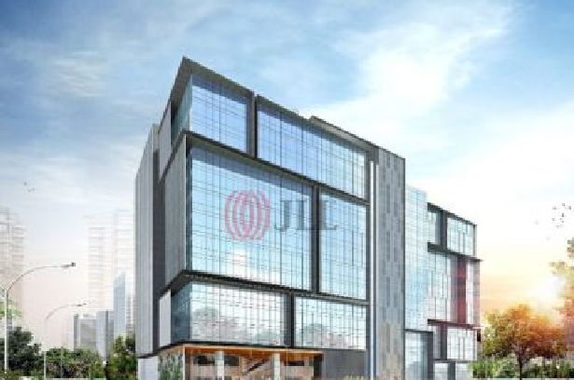

ONGOING

Trendset Jayabheri Residential Project Kondapur, Telangana

Trendset - Jayabheri Projects LLP Awarded with contract comprising of -3 block (A, B and C) having 2 basements

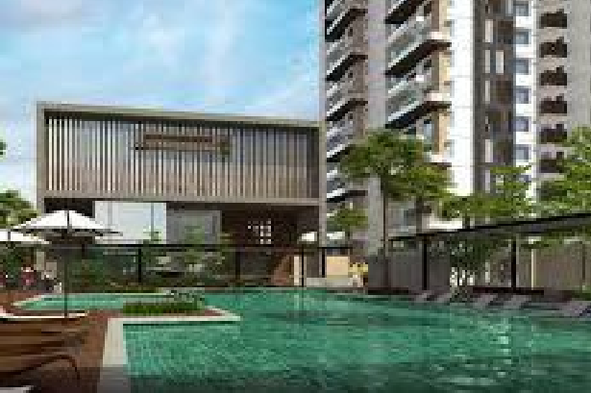

+19 floors + terrace each, total shell and core with block work, Plastering and waterproofing with a project duration of 17 Months for the proposed residential project near Kondapur, Hyderabad.

Project Location Client Description

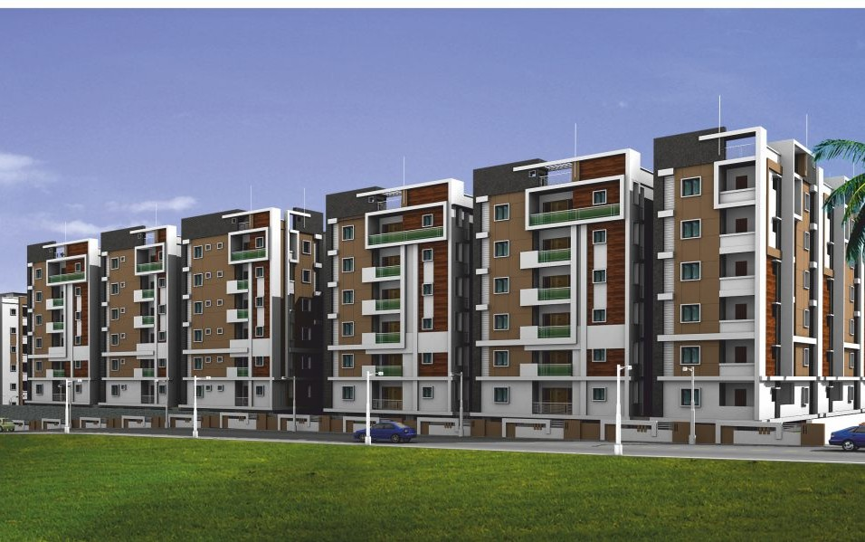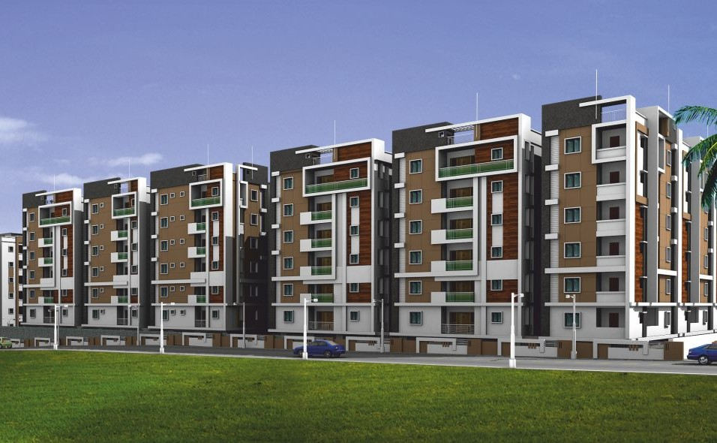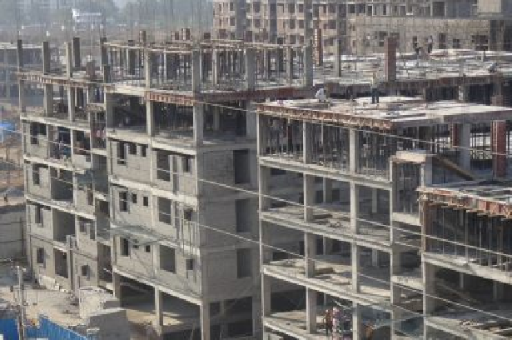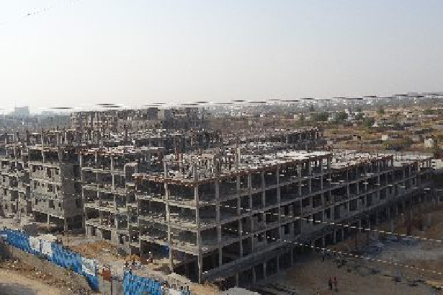

ONGOING

Luxor Apartments Kondapur, Hyderabad Trishala Infra Project Pvt. Ltd. 474 nos. (2BHK, 3BHK) of

residential apartments

Project Location Client Description

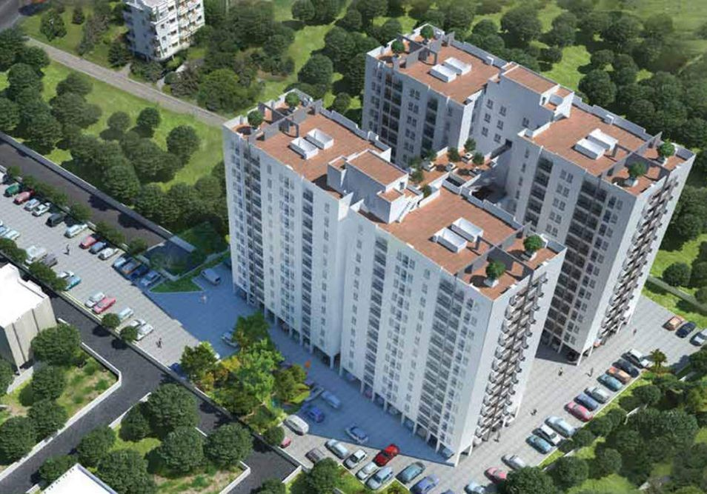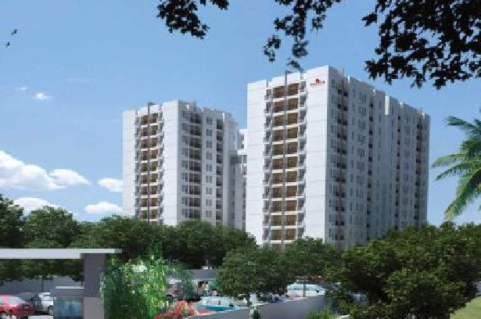

ONGOING

Navin Whiteberry Chennai

Navin Housing & Properties (P) Ltd. High-rise Residential Apartments

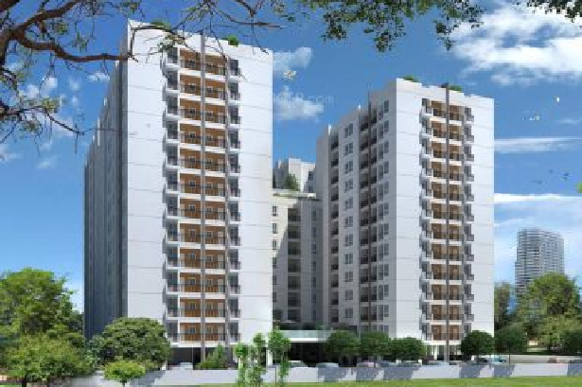

Project Location Client Description

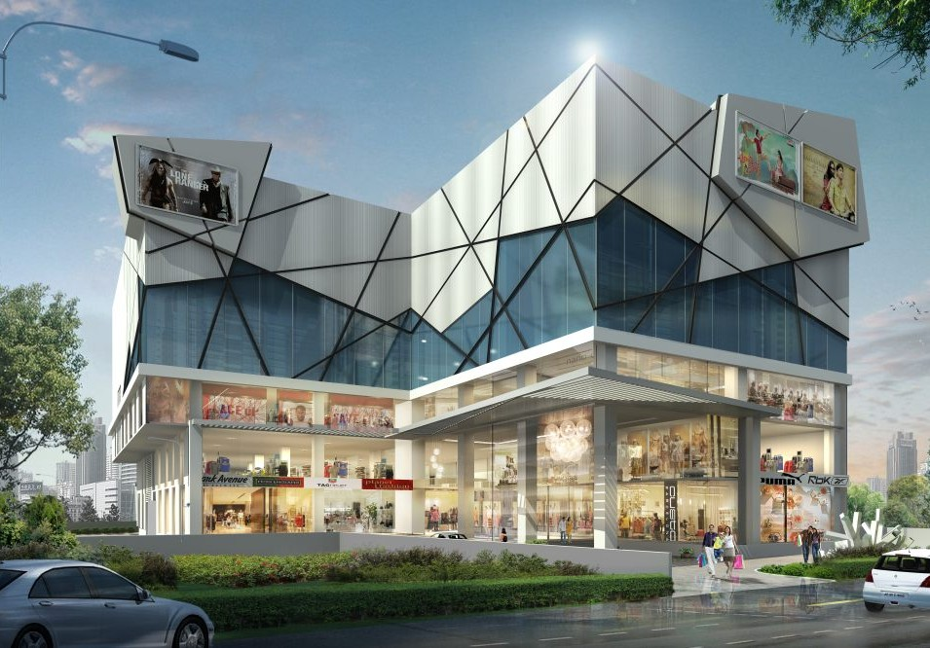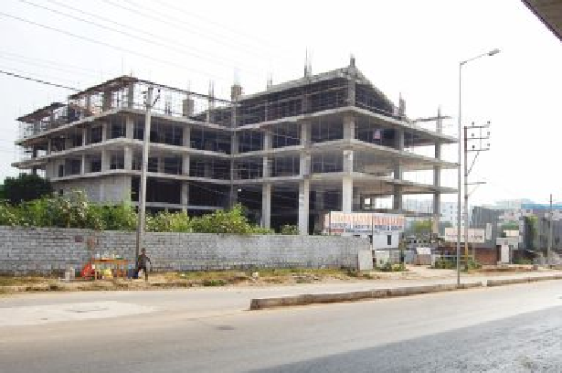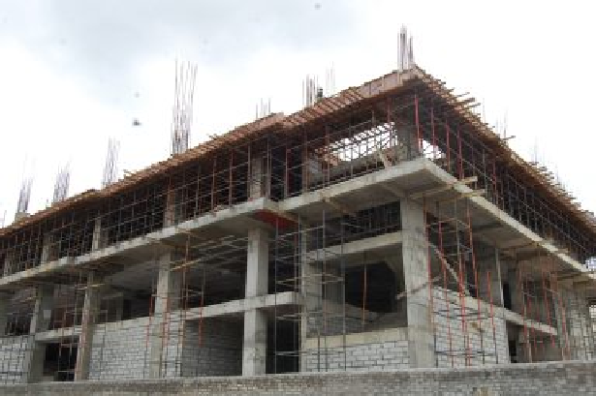

ONGOING

UPM Multiplex Upparpally, Hyderabad

Namisree Infrastructure & Projects Pvt. Ltd. 3 basement car parking, 3 floor shopping & 6 screen commercial space

Project Location

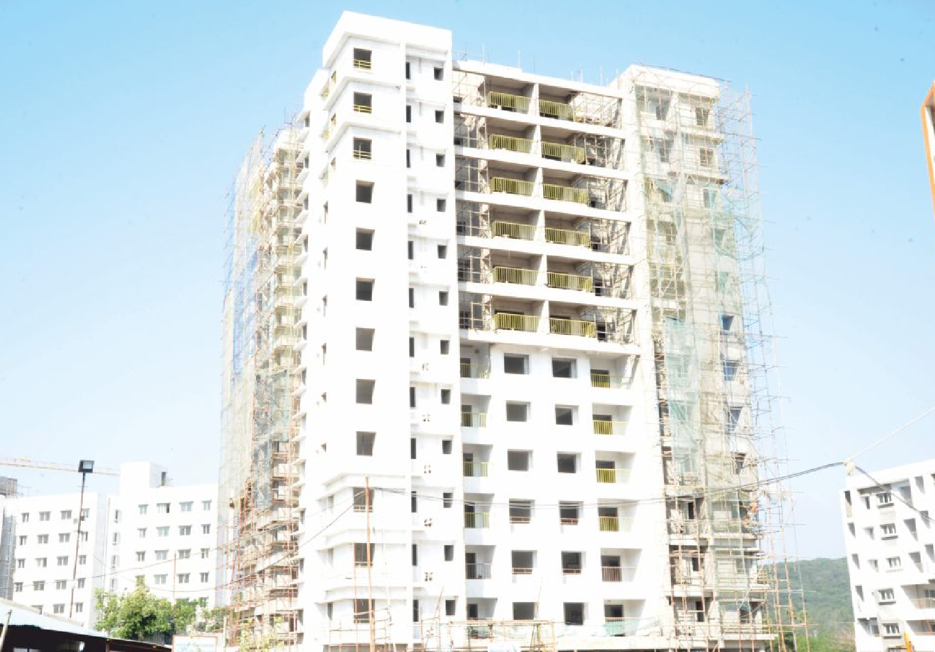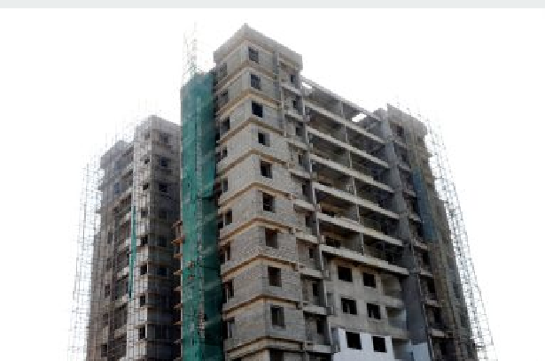

ONGOING

Client Description

Iris 3B tower

Mahindra world city, Chengalpet, Chennai

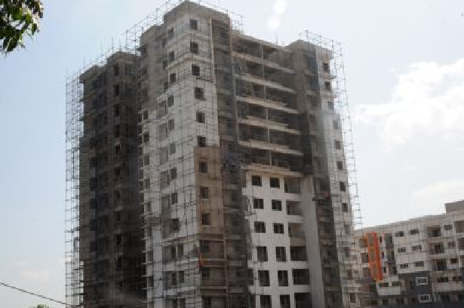

Mahindra Integrated Township Ltd. High rise residential apartments

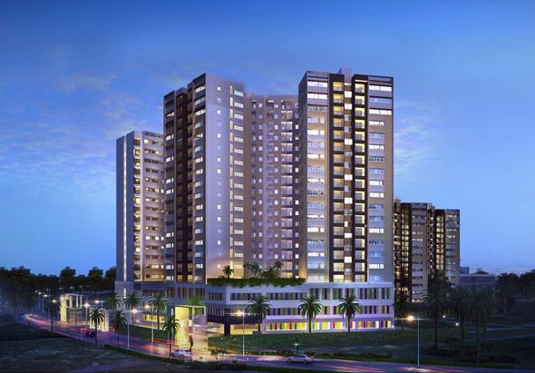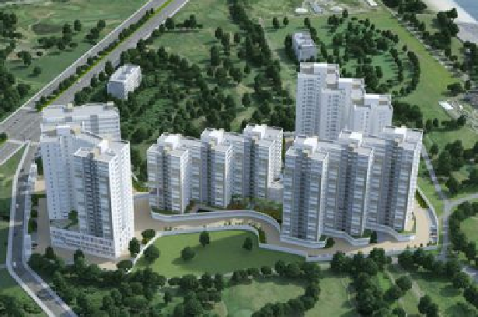

Project Location Client Description

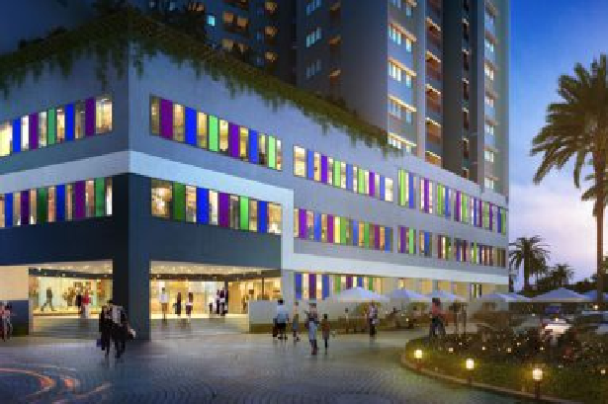

ONGOING

Godrej Azure

OMR, Padur, Tamil Nadu Godrej Properties

High-rise Residential apartments

certifications

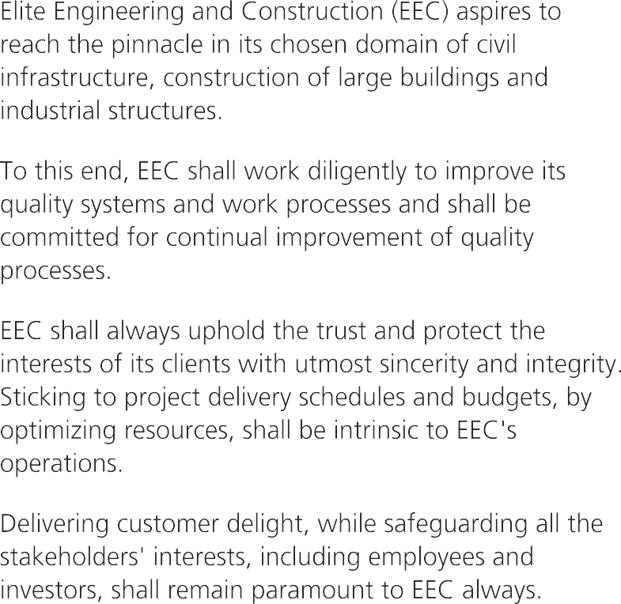

**ELITE ENGINEERING & CONSTRUCTION**

**Quality Policy**

### S V Gurusamy

Managing Director

Elite Engineering & Construction (Hyd) Pvt. Ltd. 02-12-2013

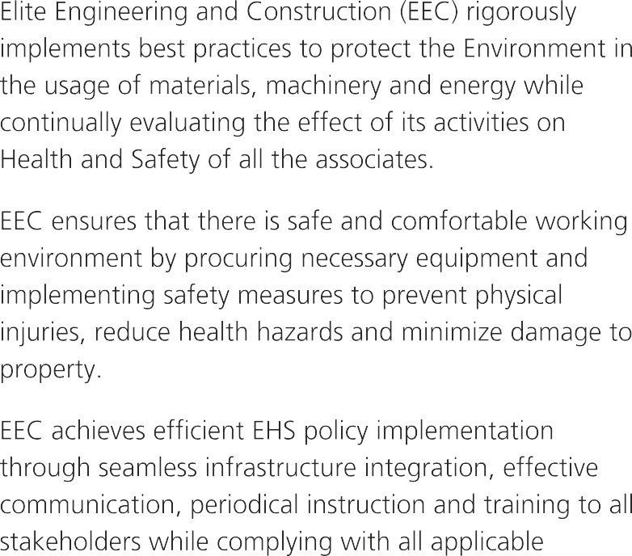

**ELITE ENGINEERING & CONSTRUCTION**

### S V Gurusamy

Managing Director

Elite Engineering & Construction (Hyd) Pvt. Ltd. 02-12-2013

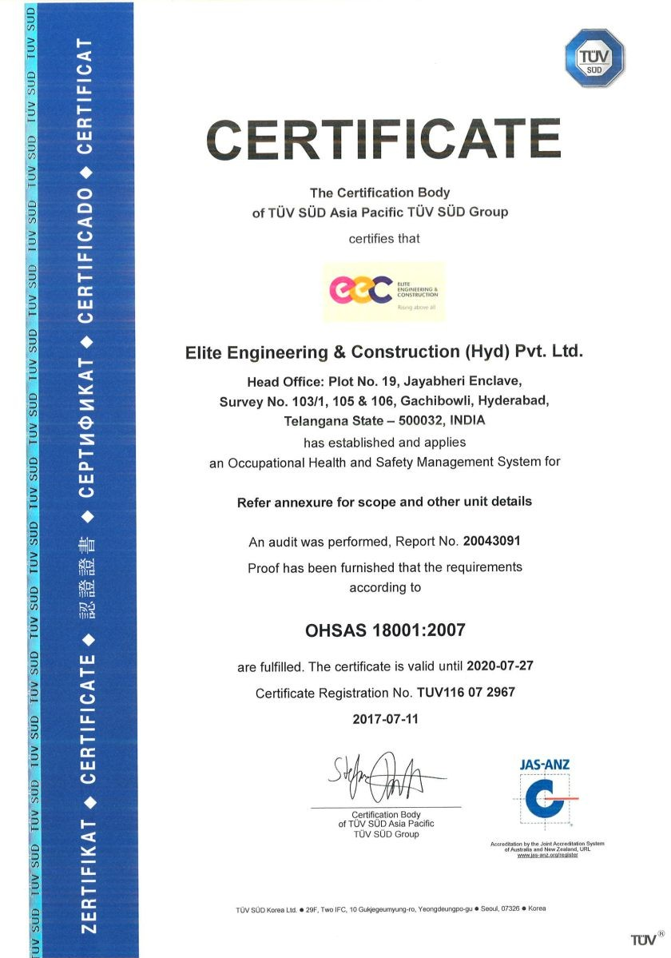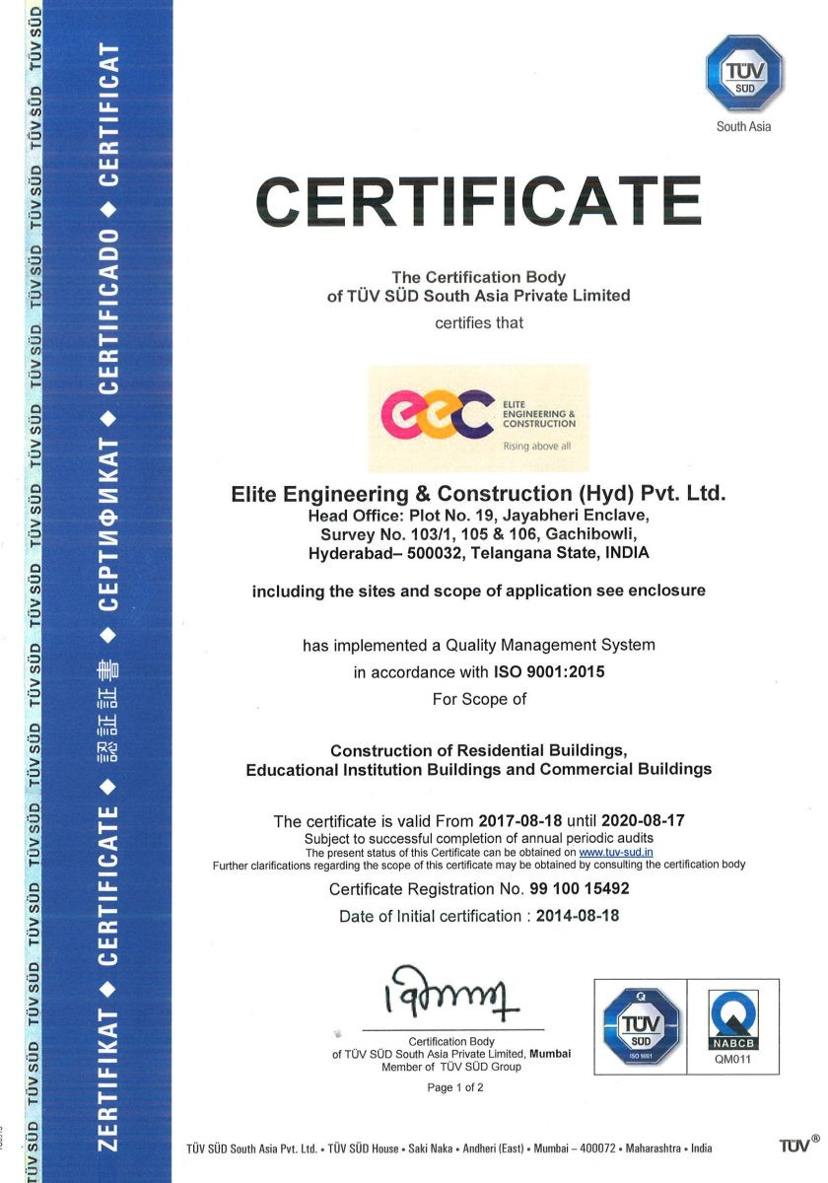







**ELITE ENGINEERING & CONSTRUCTION (HYD) PVT. LTD.**

**Corporate Office:**

Plot #19, Veda's Prime House, Jayabheri Enclave, Gachibowli Hyderabad-500032. Telangana. Tel: 91000 50801

**Branch Office:**

#18, Defence Colony, Opp. Military Hospital, Ekattuthankal Chennai-600 032. Tamil Nadu. Tel: 044-22331186/89

**Branch Office:**

#10, CMC Complex, B.C.H Road, Rajarejeswari Nagar, Bangalore, Karnataka - 560098 Tel: 94422 33801

[info@elitegroup.in](mailto:info@elitegroup.in) [www.elitegroup.in](http://www.elitegroup.in/)